Katie McConville - 17003410

Katie.mcconville@northumbria.ac.uk



Abstract

This document is the lab report for my C program that will perform calculations at the request of the program user. These calculations must include the addition, subtraction, division and multiplication of both real numbers and complex numbers, with the multiplication and division of complex numbers also giving the answer in polar form. This report shows the planning, method and testing of version 1.1.1 of this program.

Computational Laboratory work report

KD4008 2017/18 ASSIGNMENT

Contents

Introduction 1

Planning 1

Method 2

Testing 5

Conclusion 10

Appendix 11

## Introduction

The aim of this project is to design a program that will perform calculation on request by the program user. The possible calculations include addition, subtraction, multiplication and division for both real numbers and complex numbers.

## Planning

To start this project, I had to begin by planning out the program step by step, to know what needs to be included in the program and how is best to organise it, and how different parts of the program need to link into each other.

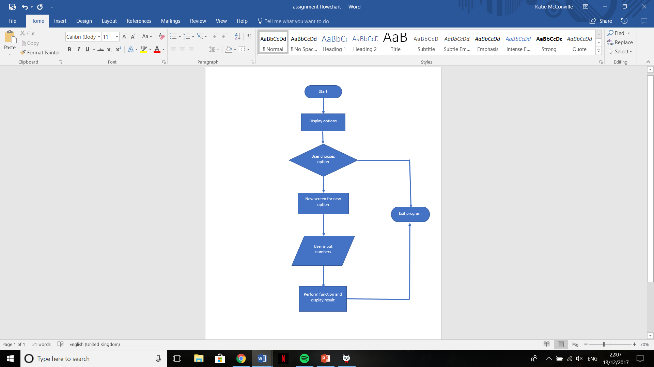I started with a very simplistic initial flow chart, to begin considering the steps that need to go into it. This is seen in Figure 1. In Figure 2, you can see a further developed flow chart, with each individual function mapped out with their assigned labels, A to H. I also included the definition of variables, functions etc at the start of the system.

Figure 1 – First draft of the flow chart

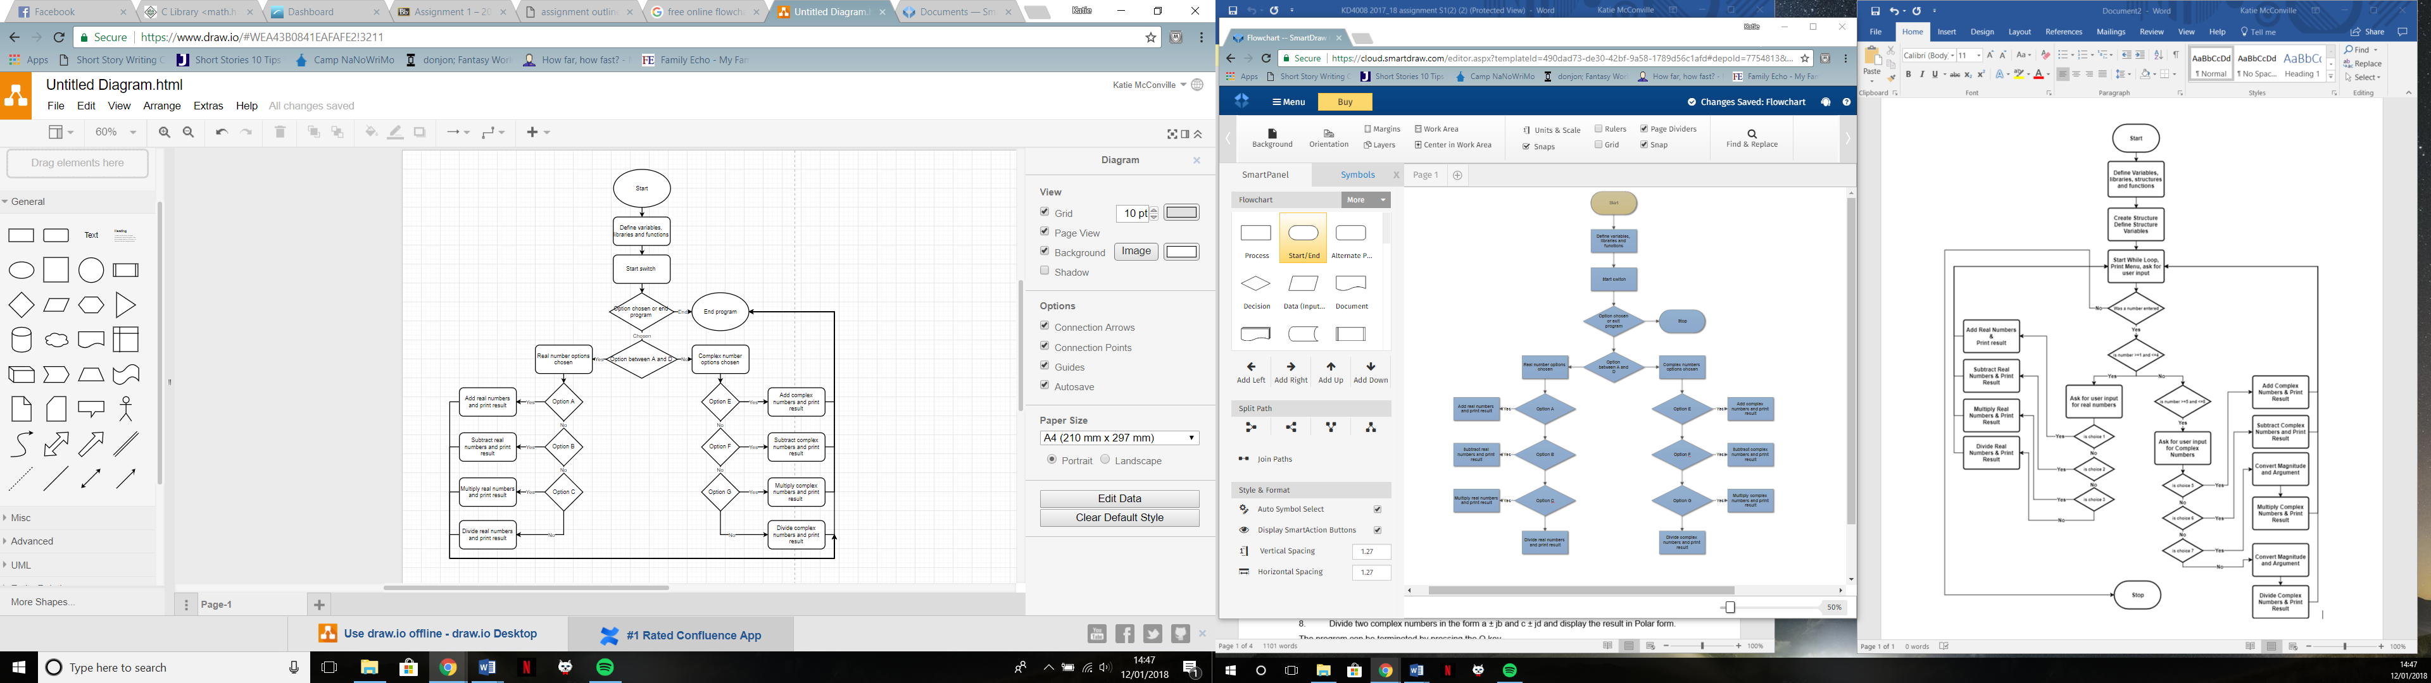

Figure 2 – The completed flow chart

## Method

The program begins with the declaration of the needed libraries, the variables and what type of variable they are and the labels for functions. The <math.h> library enabled the use of the tan-1 function for the complex number multiplication and division, but in the program it is referred to as ‘atan’.

All of my variables, bar two, are declared as floats. The reason for this is that I wanted to keep as small a number of variables as possible to prevent confusion, but for division of real numbers it would have to be able to give the result as a decimal, as it isn’t guaranteed the user will choose numbers that divide into integers. The usage of decimals is also useful in the complex numbers multiplication and division for the argument of the answers when in polar form. However all of my decimals are rounded to a certain degree of accuracy.

I have declared pi as a ‘const double’, which means it is a value within the program that should not be changed at all. I needed to include pi for options G and H, to convert the arguments for the polar numbers into degrees, rather than working in radians which is the default.

A major part of this program is the menu system. For this, I used a switch and case system. This starts with the printing of all the potential options for the user to read, and they then have the opportunity to type in their choice. This input is called “chosen” and is retrieved using the “getchar” function. We then tell the program that the switch will be based on what is found in “chosen”. After this is a series of sub-programs for each possible option, each beginning with the command “case ‘X’:”, with X being in place of the label for that function. This system works as a go to, so if the input for ‘chosen’ was B, then the program will go to “case ‘B’:” in the program, and carry out the subprogram that follows it.

I chose to use a switch and case system because it was simple to use and offered a modular format most appropriate for this type of program. It also allows the usage of as many options as necessary.

Every option in the list featured a ‘\n’, which means that each printf statement is on a new line, so as to make it clearer and easier for the user.

Each subprogram starts with the command “system (“cls”);”, which clears the screen of the menu, so as to prevent any possible user confusion. It will then print a statement letting the user know what option it was they selected. Options A to D are the real number options, and have the same format. They begin by asking the user for the two numbers they want to use. This input is scanned, and registered to the variables ‘a’ and ‘b’. Then the necessary calculation for the sub-program is carried out, with the answer being labelled ‘c’. These calculations are:

a + b = c;

a – b = c;

a*b = c;

a/b = c;

The result of these calculations is then printed for the user to see. For everything except division, the variable is told to print to zero decimal places, as annotated with ‘%.0f’. After this, the user can then press enter in order to exit the program.

Options E and F are the addition and subtraction of complex numbers. They require four variables, labelled ‘a’, ’b’, ’c’ and ’d’. The calculations for these are then done, to get the real and imaginary values. These are:

For addition:

real = a + c;

img = b + d;

For subtraction:

real = a - c;

img = b - d;

These answers are then put into the print statement, for example for addition it would look like:

printf("Sum of two complex numbers = %.0f + %.0fi",real,img);

Once again, I have rounded the floats to one decimal place. The printf statements for both addition and subtraction are part of if statements. This is so that if the imaginary number is greater than 0, then an addition symbol is present before it, but if the value is negative it will already have a sign attached to it. For these two options, the result is printed in rectangular form.

Option G is the multiplication of two complex numbers, where the answer is required in polar form. First I get my four variables from user input as before, but for this I need to convert my numbers into polar form before multiplying them. The code I used is:

po1mag= sqrt((a*a)+(b*b));

po1angle=atan(b/a)*(180/pi);

po2mag= sqrt((c*c)+(d*d));

po2angle=atan(d/c)*(180/pi);

Where to get the magnitude I need to square root the squares of both aspects of the function added together, and to get the argument, which in my program is labelled as the angle, I need to do the inverse tan of the imaginary divided by the real. This is then converted into degrees, as asked for in the brief. Now that I have formatted the numbers as needed, I can then multiply them. To multiply complex numbers, you have to separate them into magnitude and argument. The magnitudes of each are multiplied together, and the arguments of each are added, giving you your final answer. The calculations as written in my program are:

polarmag=po1mag*po2mag;

polarangle=(po1angle+po2angle);

These results are then printed to the user with the printf statement here:

printf("Multiplication of two complex numbers in polar form is %.0f < %.2f degrees",polarmag,polarangle);

Option H is the division of complex numbers. Once again, the four variables are first input, but at this point we had to include a rule that would check the values of the second complex number, which will be our denominator, and ensure that neither number is 0. This is because obviously you can’t divide by zero, so to try would give an error. If a user tries to do this, they are given an if statement informing them. The program for this rule and following statement is:

{ if ( c == 0 || d == 0 )

printf("Division by 0 is not allowed.");

else

Where the else statement leads to the calculations for this section. Once again, we have to convert the complex number to polar form before we can perform the division aspect, this is done the same way as shown for option G, and the values are given the same labels. We can then divide the numbers. This is done by dividing the first magnitude by the second, and subtracting the second argument from the first. In the program, this looks like:

polarmag= po1mag/po2mag;

polarangle=po1angle-po2angle;

The results of these calculations are then printed for the user in this printf statement:

printf("Division of two complex numbers in polar form is %.0f %.2f",polarmag,polarangle);

The final option is option Q, which works to let the user exit the program immediately without choosing to perform any of the possible options.

At the end of each subprogram, there is a line that says “return(0);”, which means that the user will then be prompted to press enter in order to exit the program back to Quincy.

## Testing

Upon completion of the program I began to enter the testing phase. Figure 3 shows the menu upon running the program. For parts A to D I checked all of my results using a calculator.

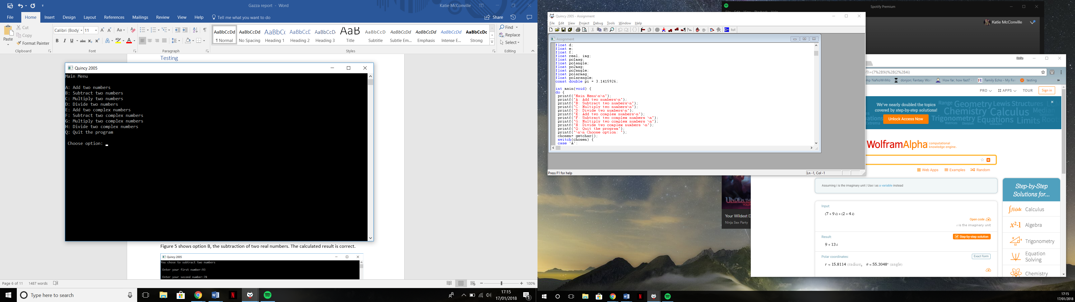

Figure 3 - The menu screen

Figure 4 shows my program calculating a result to option A. The calculated result is correct. Figure 5 shows that the program still works when being asked to work with negative numbers, and the result is also correct.

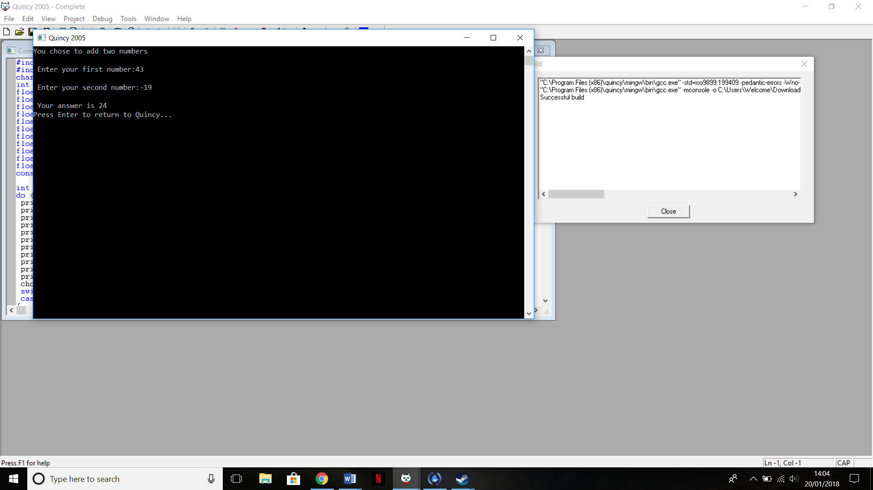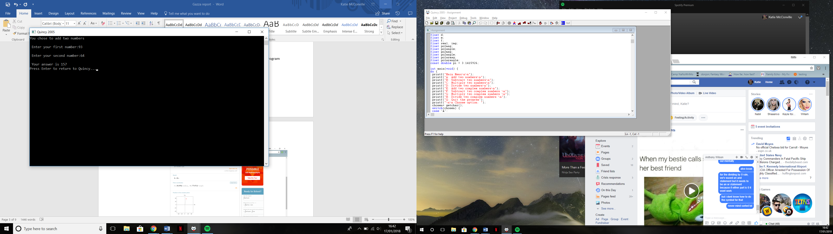

Figure 5- Option A, addition of two real numbers including negatives

Figure 4 - Option A, addition of two real numbers

Figure 6 shows option B, the subtraction of two real numbers. The calculated result is correct. Figure 7 shows that the program works with negative numbers, as the result is correct.

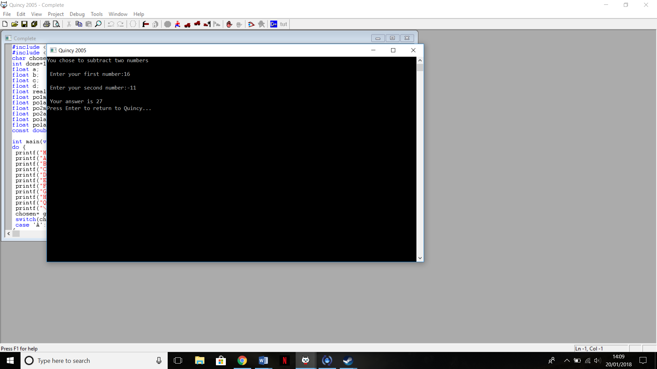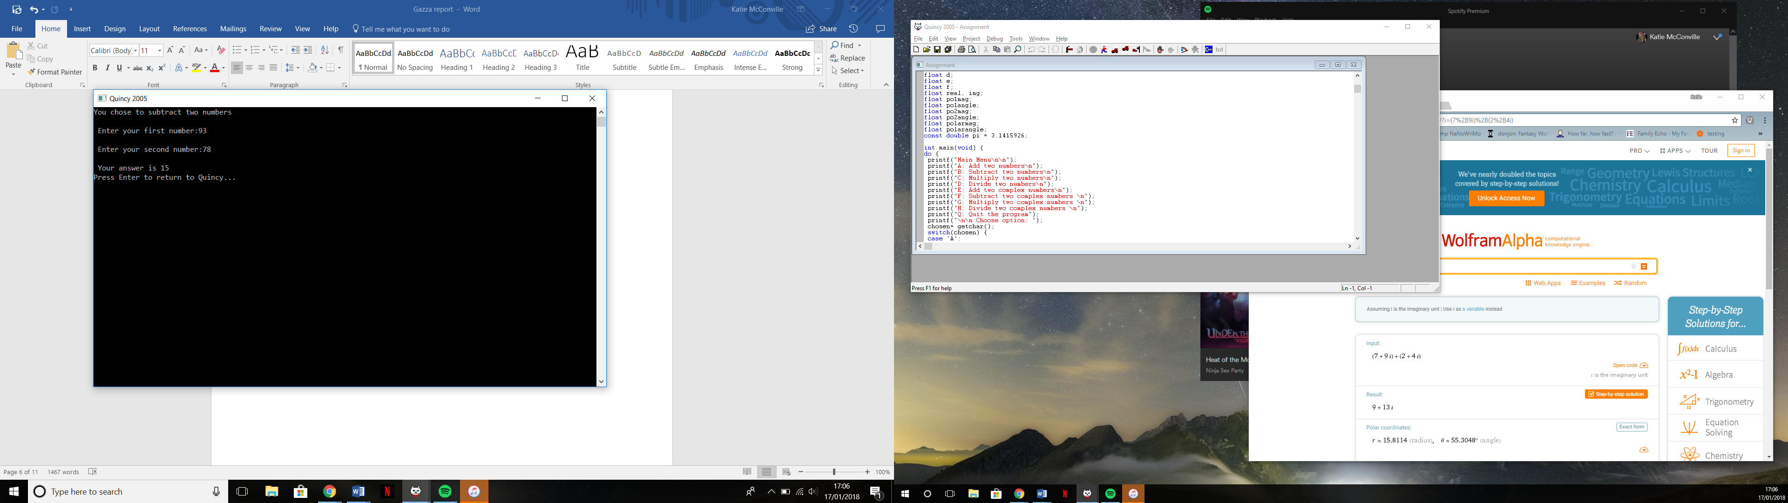

Figure 7 - Option B, subtraction of two real numbers including negatives

Figure 6 - Option B, subtraction of two real numbers

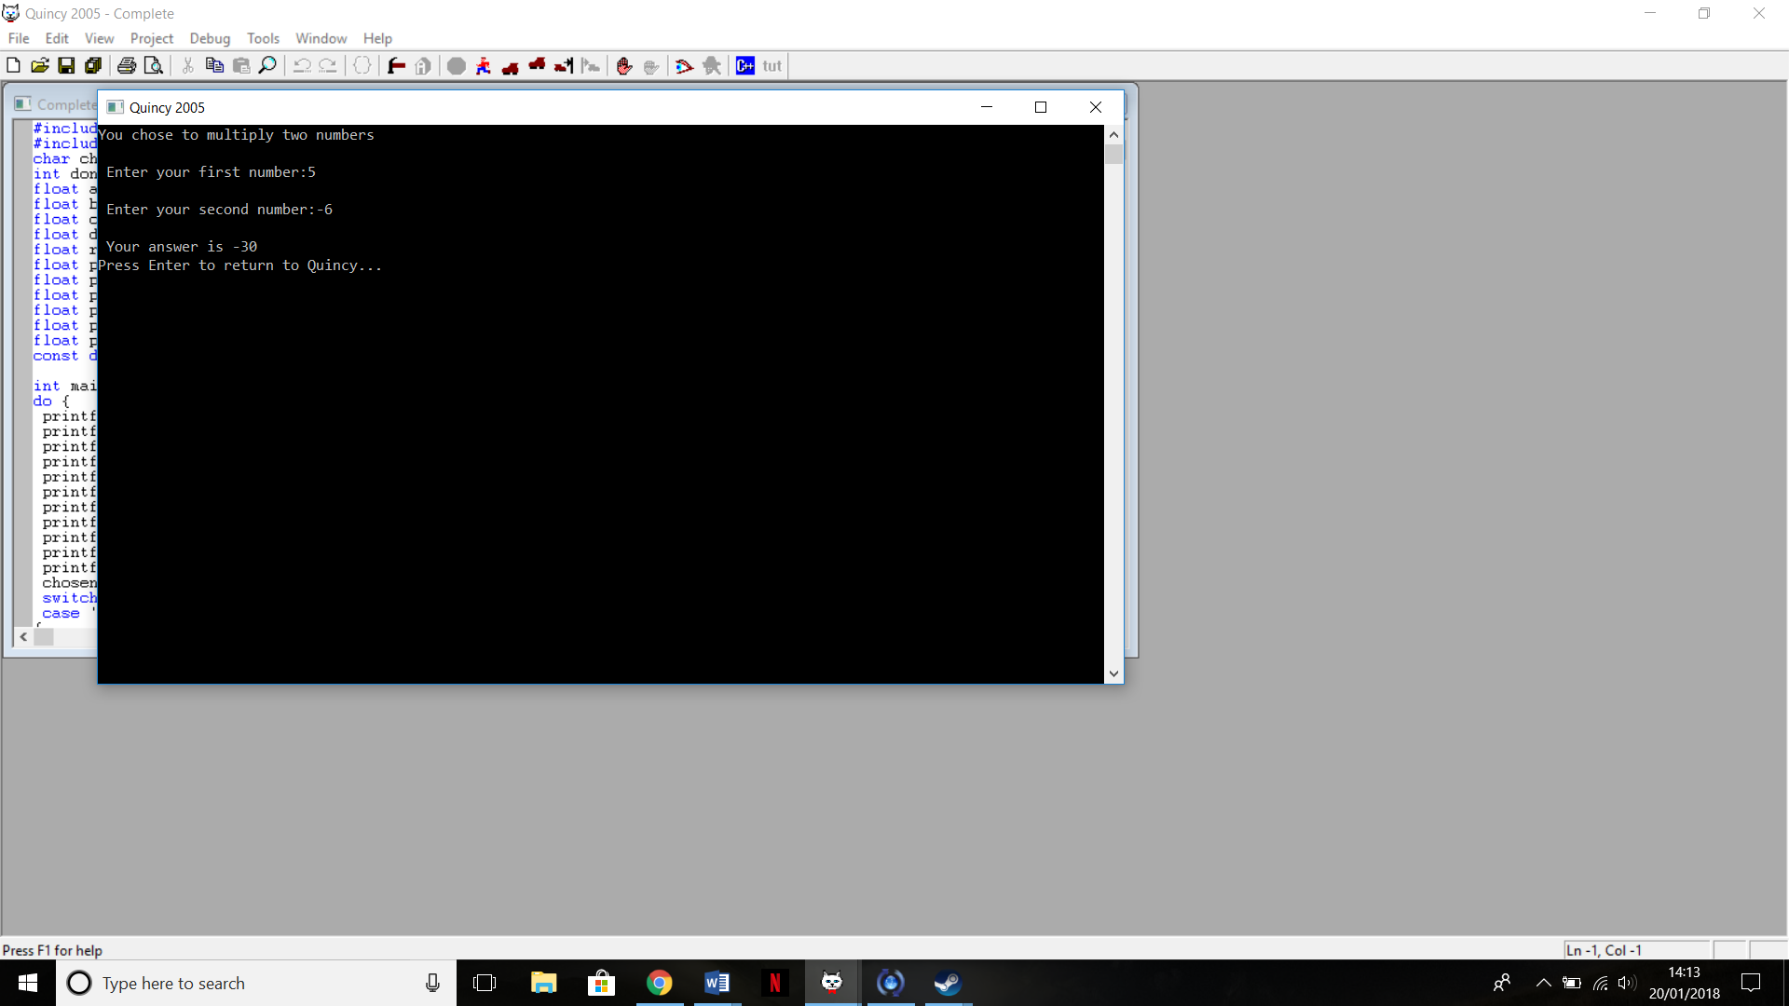Figure 8 shows option C, the multiplication of two real numbers. The number calculated is correct. Figure 9 shows the correct answer for a calculation involving negative numbers.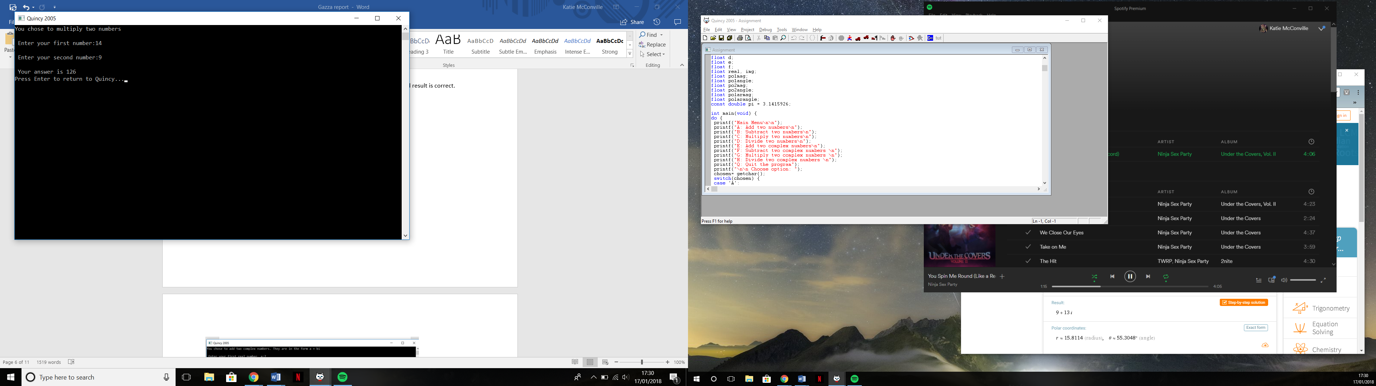

Figure 9 - Option C, the multiplication of two real numbers including negatives

Figure 8 - Option C, the multiplication of two real numbers

Figure 10 shows option D, the division of two real numbers. The number calculated is correct, and shows to the number of decimal places I set it to, rounding the number appropriately. Figure 11 shows that the program can work with negative numbers.

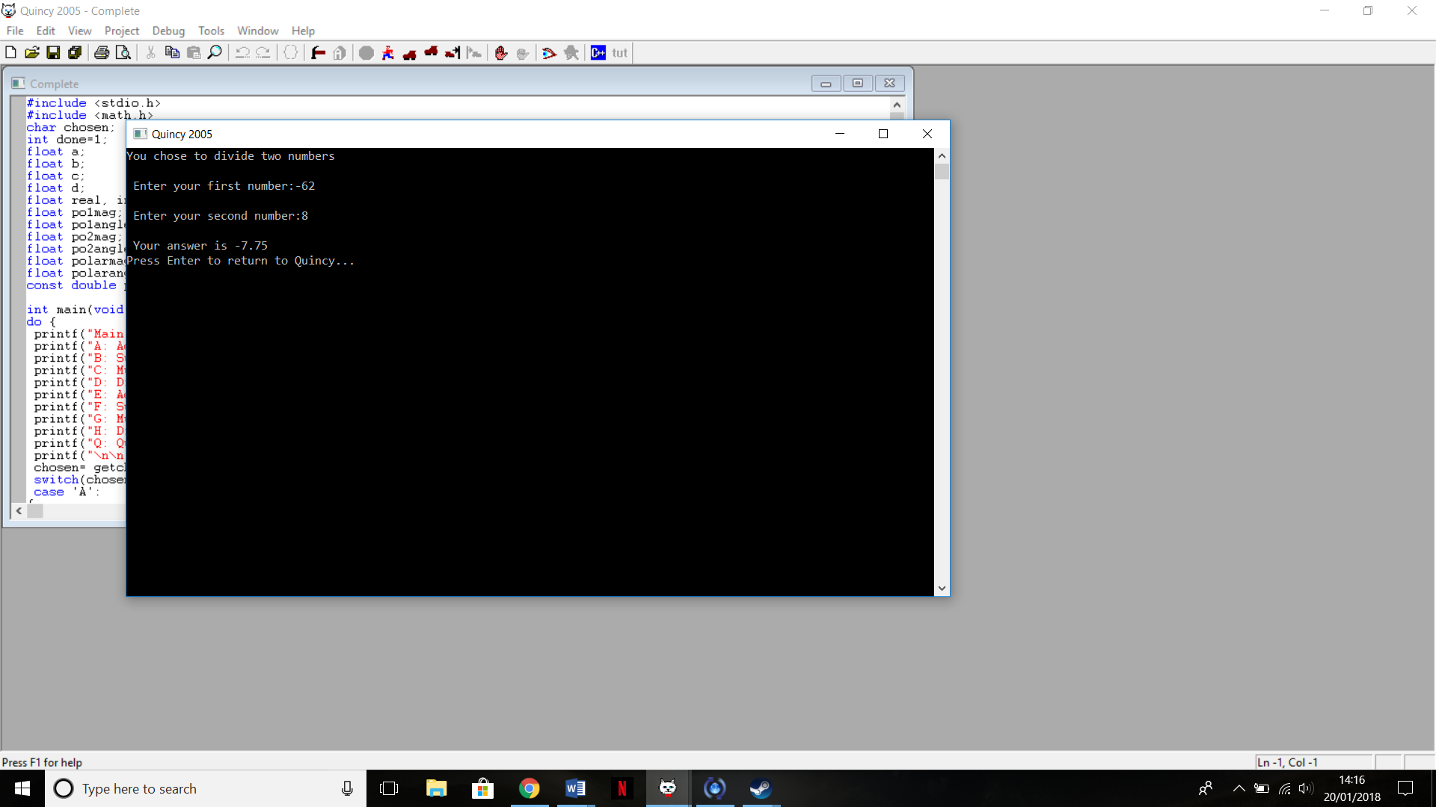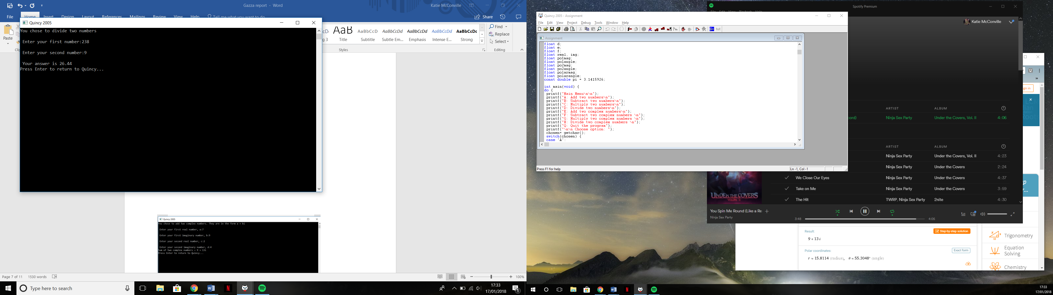

Figure 11 - Option D, the division of two real numbers including negatives

Figure 10 - Option D, the division of two real numbers

Now we move on to the complex number part of the program. For this, I used Wolfram Alpha’s complex number calculator to verify all my results. Figure 12 shows the answer produced by my program for Option E, the addition of two complex numbers, and figure 13 proves that this is correct.

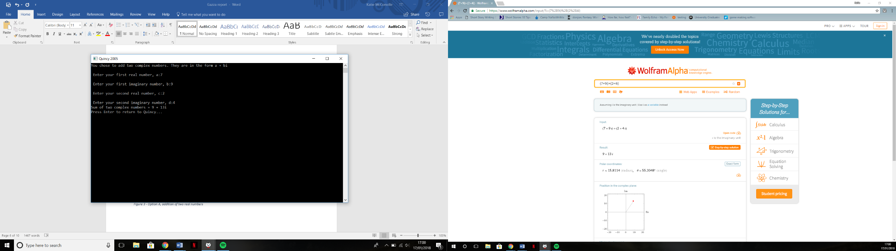

Figure 13 - Evidence of option E working correctly

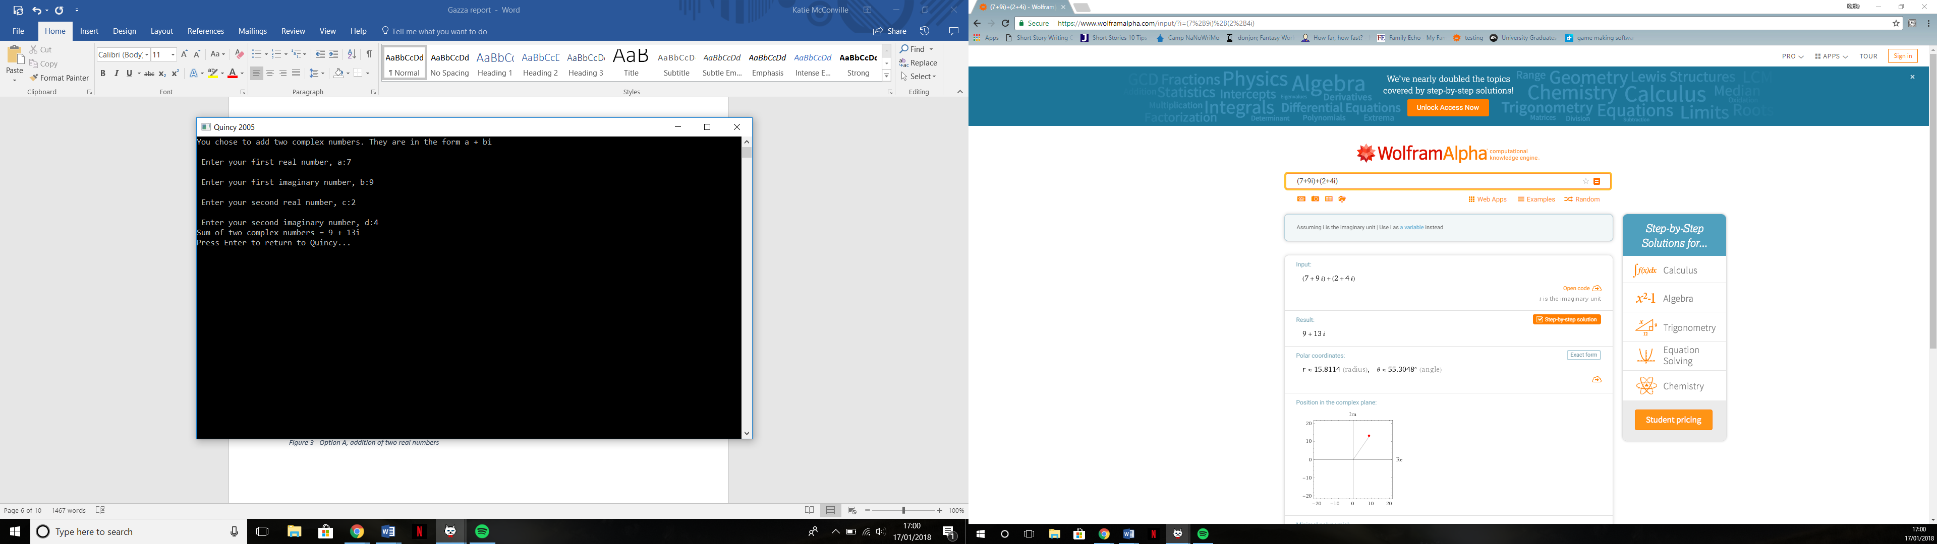

Figure 12 - Option E, the addition of two complex numbers

Figure 14 shows Option F, the subtraction of two complex numbers, and figure 15 shows that this calculated figure is correct. The numbers used give a negative imaginary number, and the fact that this displays properly shows that the ‘if’ statement put in works correctly.

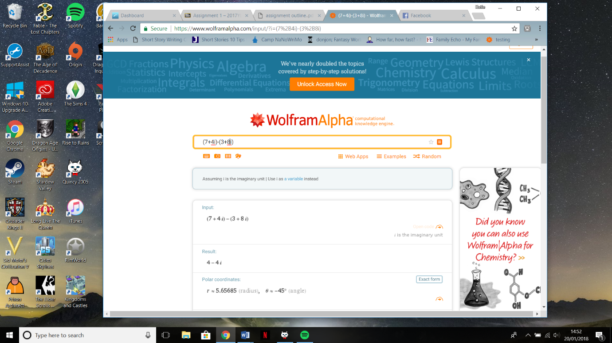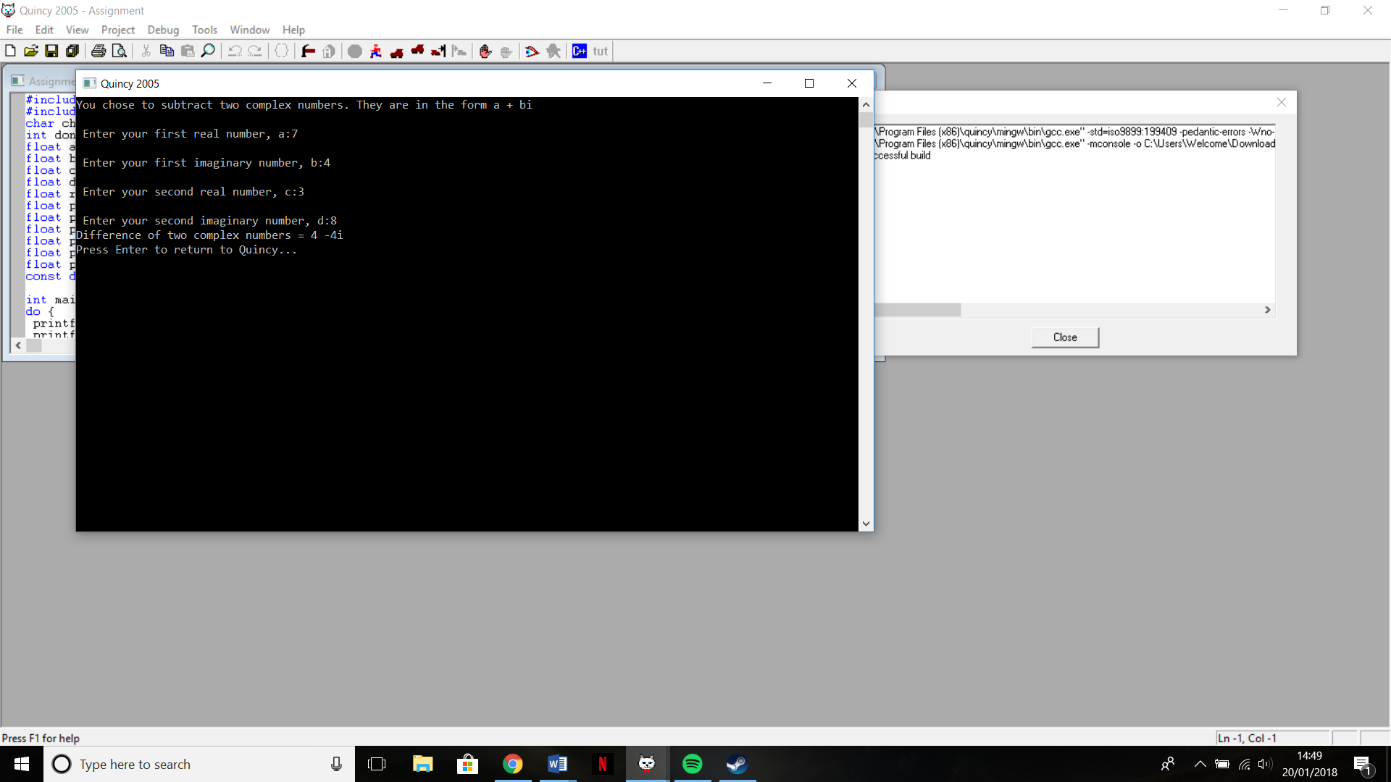

Figure 15 - Evidence that option F works correctly

Figure 14 - Option F, the subtraction of complex numbers

For options G and H, the multiplication and division of real numbers, we need to test it working in each of the four quadrants of the argand diagram, which is part of why I chose to use Wolfram Alpha to calculate the correct results, as it displays this information automatically. Figure 16 shows my calculations and figure 17 shows the result in Wolfram Alpha.

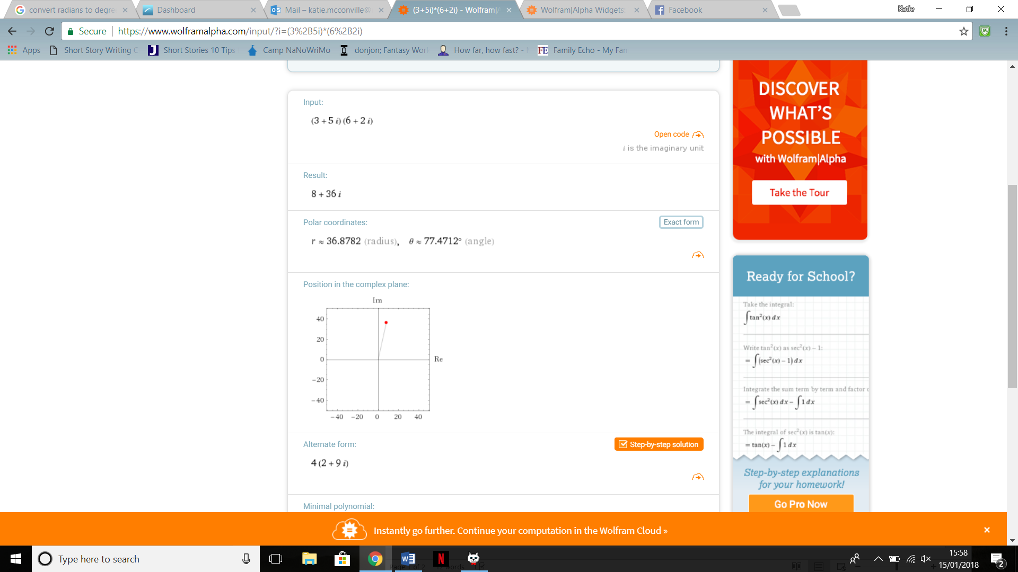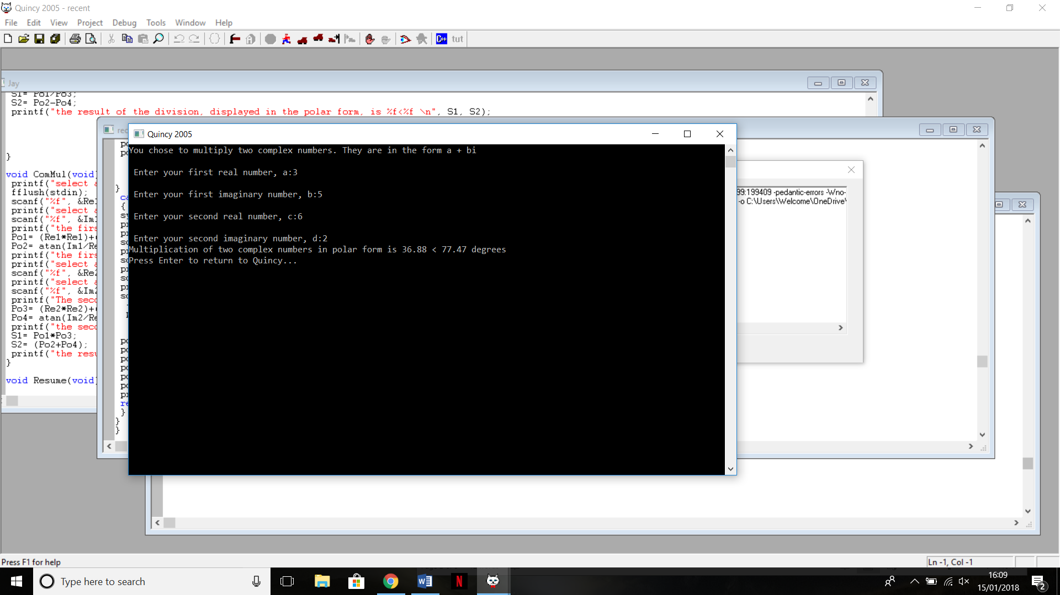

Figure 17 - Evidence for Option F working correctly in the top right quadrant

Figure 16 - Option F, multiplication of complex numbers with a result in the top right quadrant

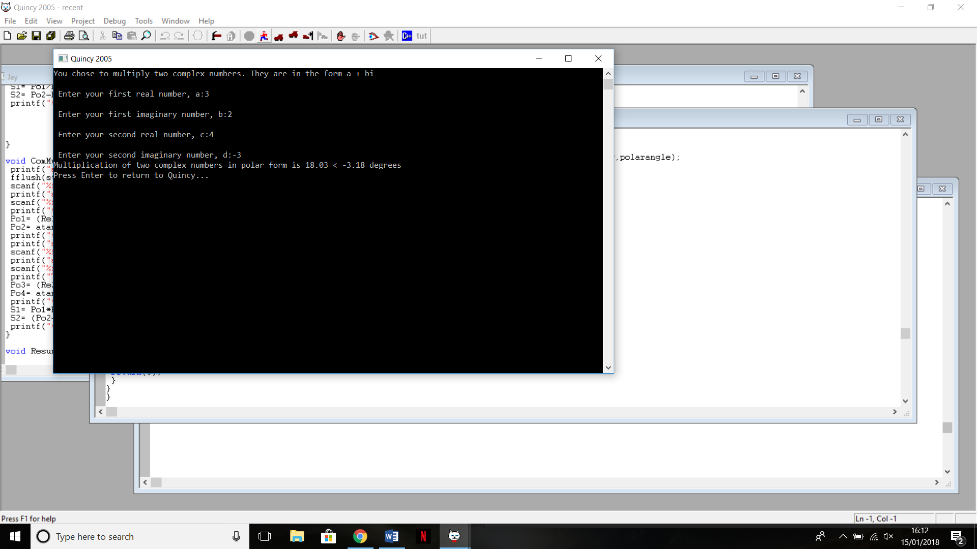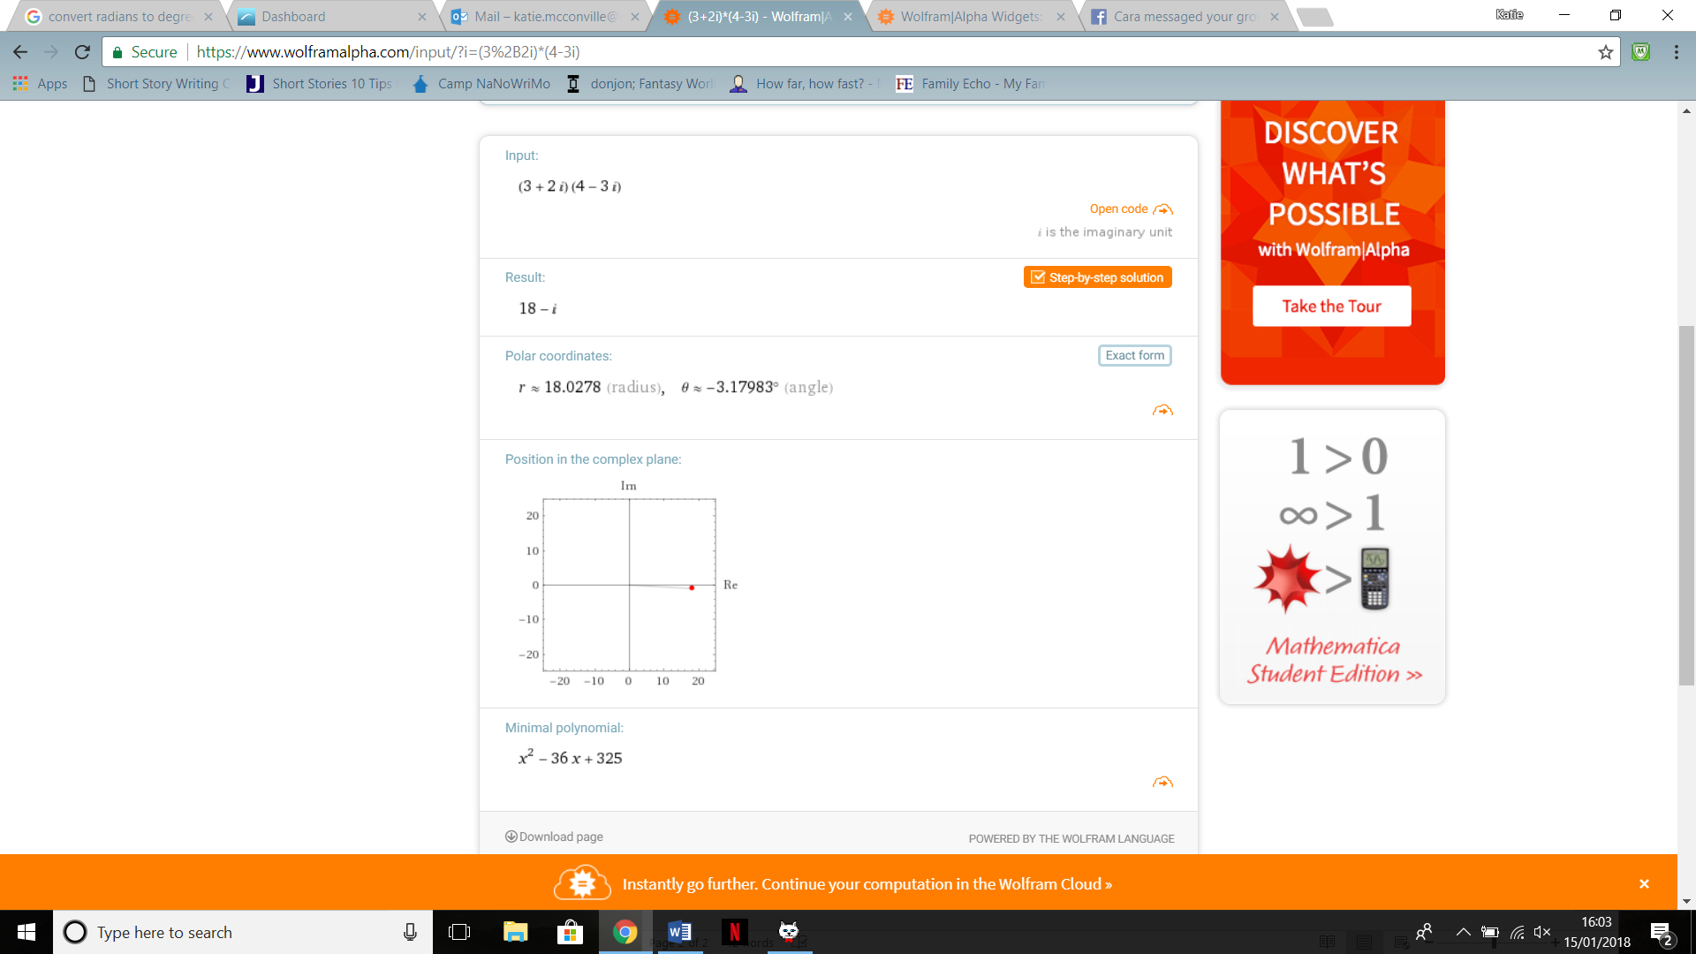Figure 18 shows option G the addition of complex numbers in the bottom right quadrant, and figure 19 is the evidence of this being the correct answer.

Figure 18 - Option G, multiplication of two complex numbers with a result in the bottom right quadrant

Figure 19 - Evidence for Option F working correctly in the bottom right quadrant

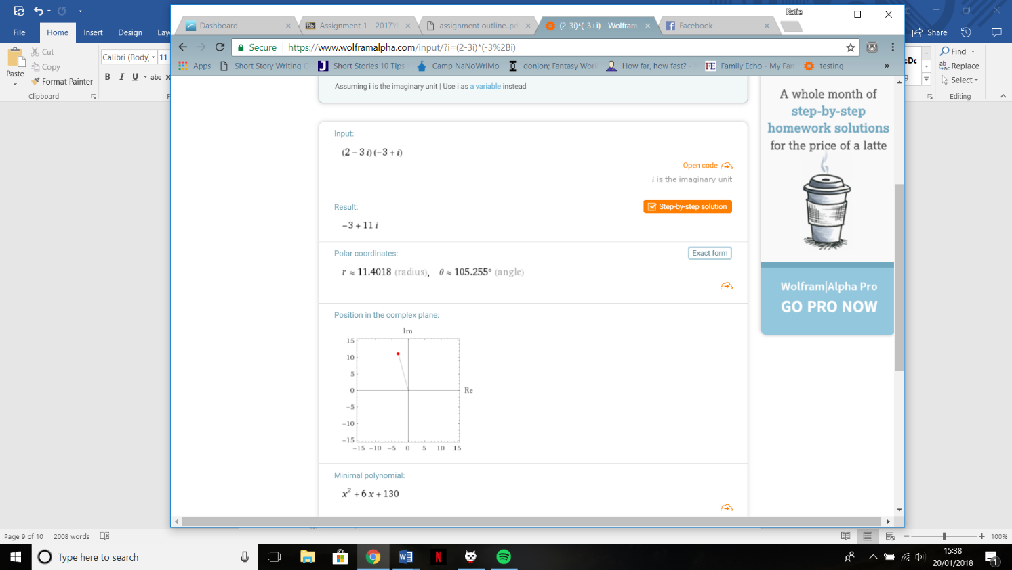Figure 20 shows option G in the top left quadrant and was where we first saw issue with the program. Figure 21 shows the actual results of multiplying these two complex numbers, and showed that our answer would need to have 180 added to the argument in order to be the correct answer. The magnitude was correct.

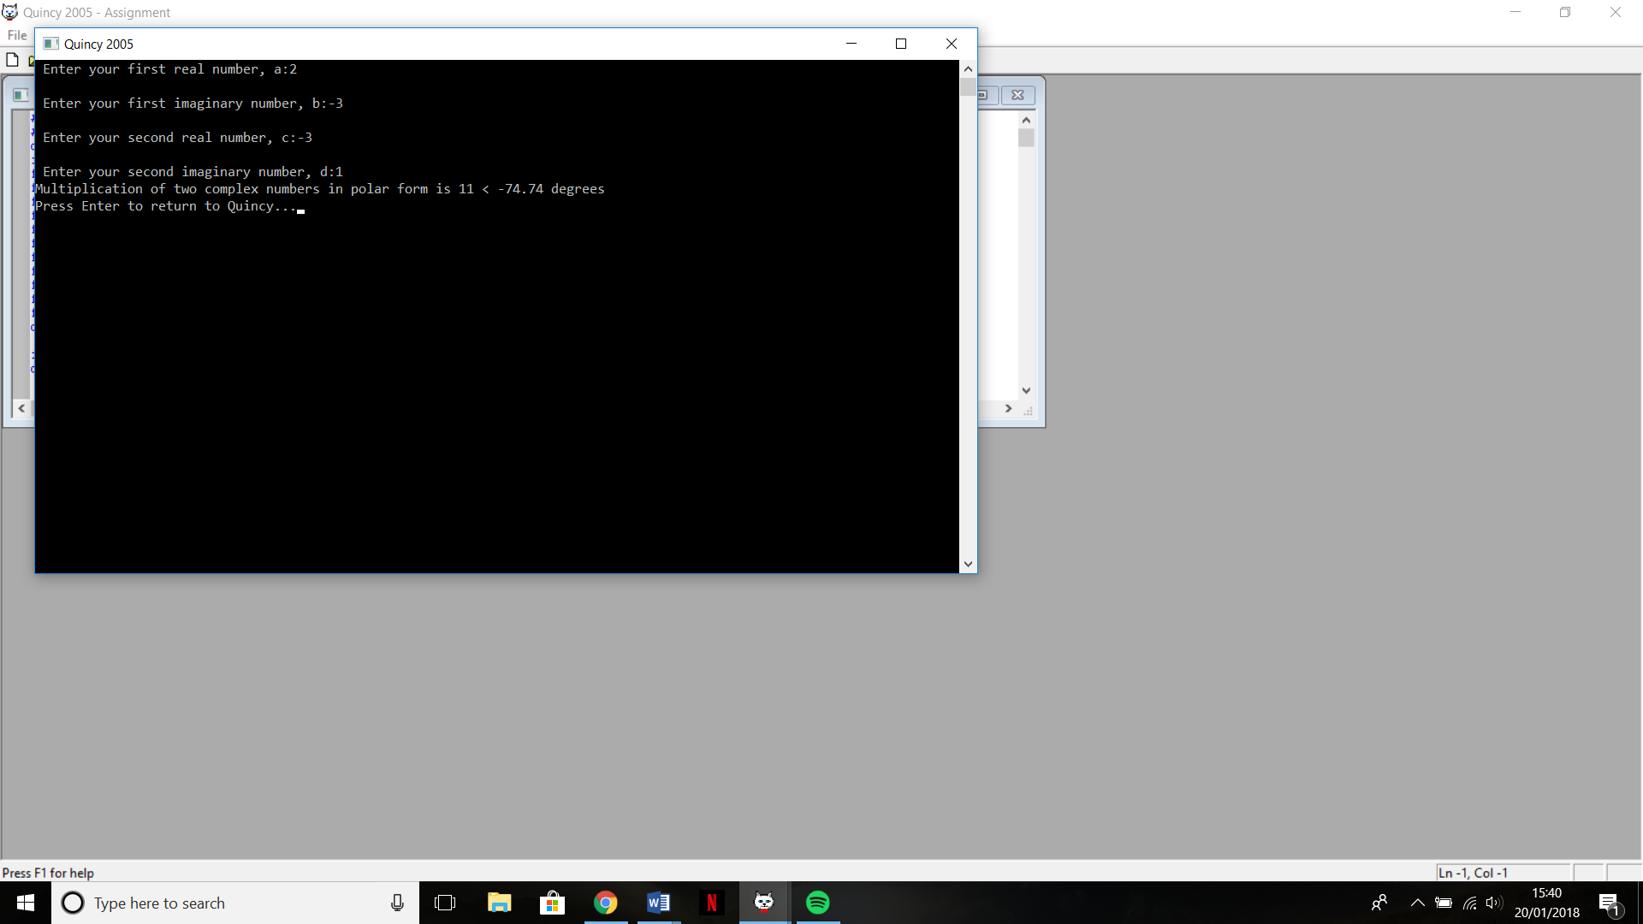

Figure 21 - Evidence for Option F in the top left quadrant, shows the actual result

Figure 20 - Option G, multiplication of two complex numbers with the result in the top left quadrant

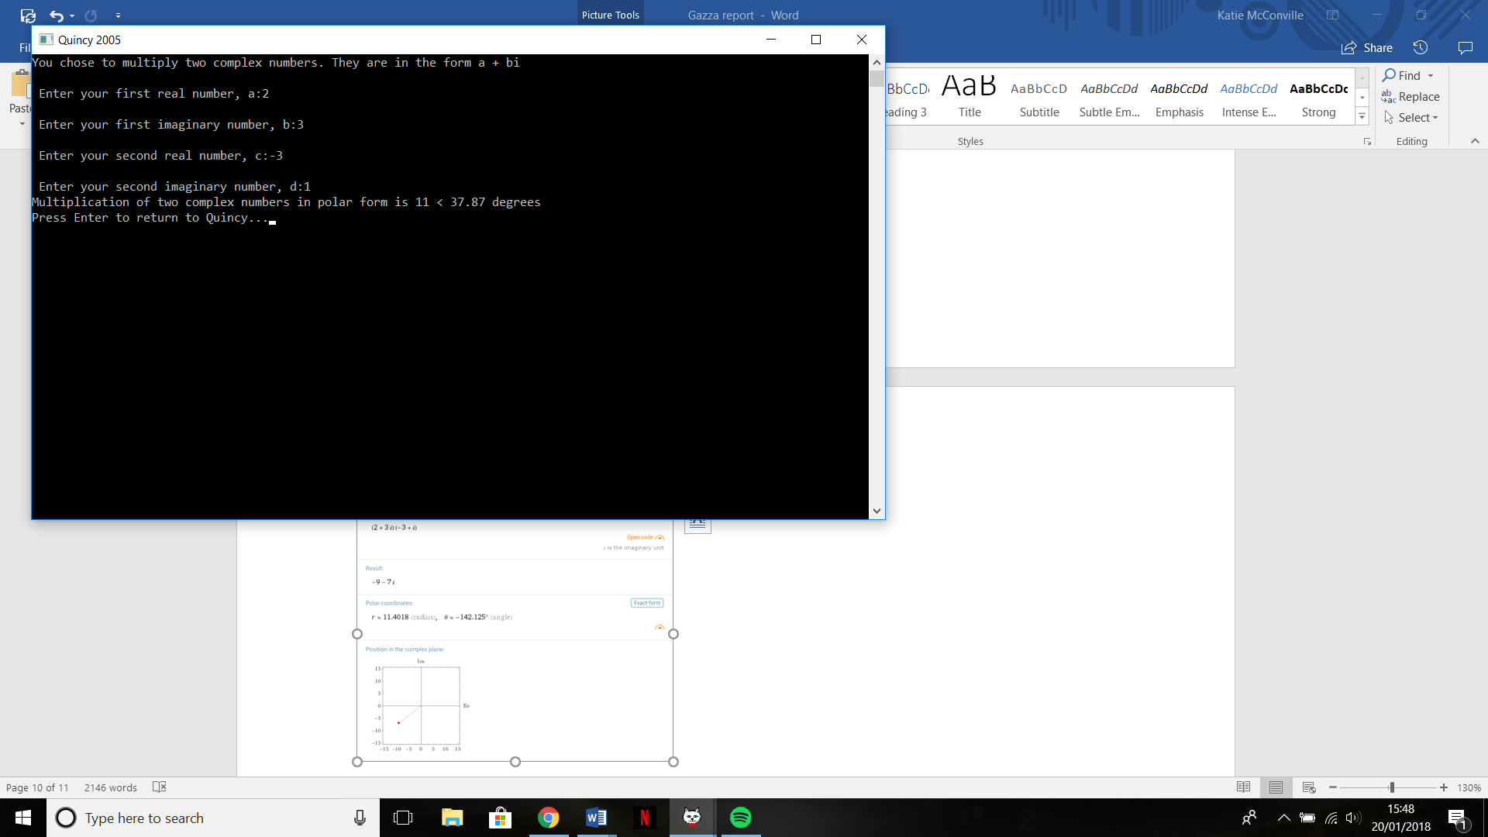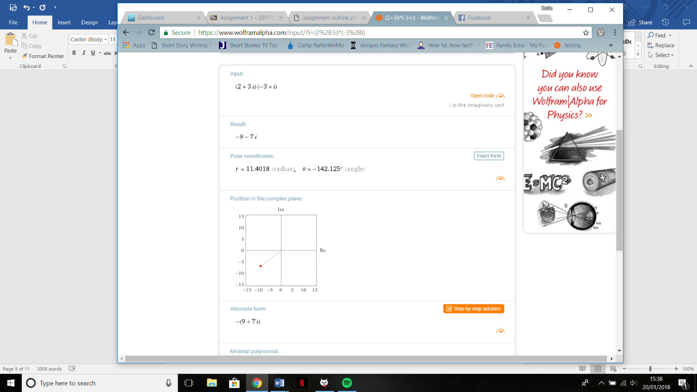Figure 22 shows Option G in the bottom left quadrant, and also presents an issue. Figure 23 shows the correct answer for the calculation, and shows we would have to subtract 180 from the argument in order to have the correct answer. The magnitude was correct, however.

Figure 22 - Option G, multiplication of two complex numbers with the result in the bottom left quadrant

Figure 23 - Evidence for option G in the bottom left quadrant, showing the actual result

We then move on to using Option H, the division of complex numbers. The result for this is also printed in polar form. Figure 24 shows this option with a result in the top right quadrant. Figure 25 shows the working out for this, and shows that it is correct in this quadrant.

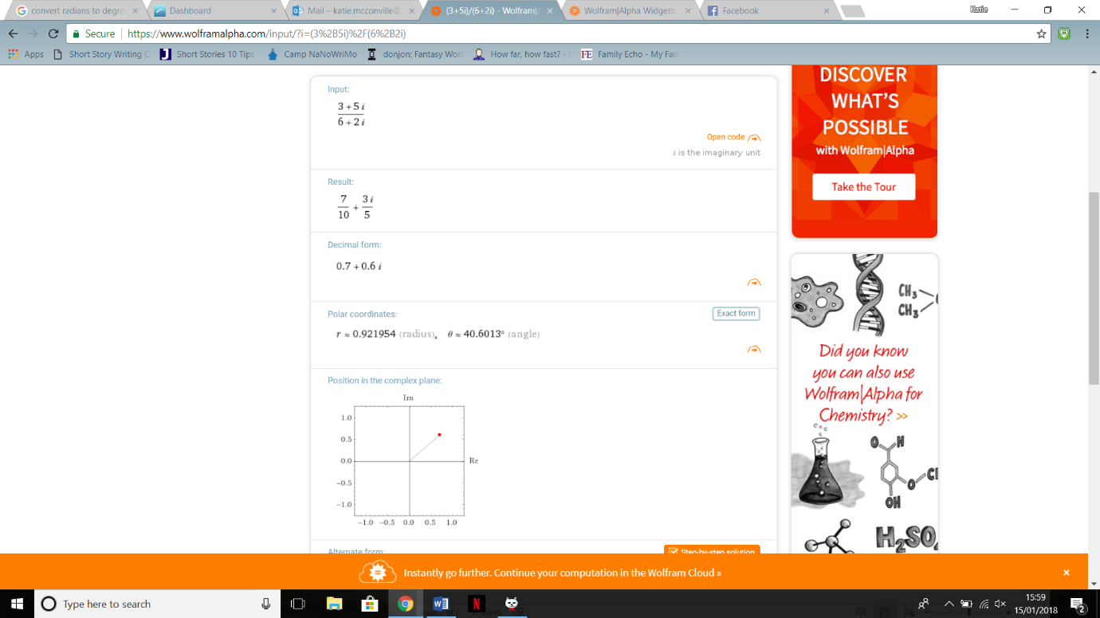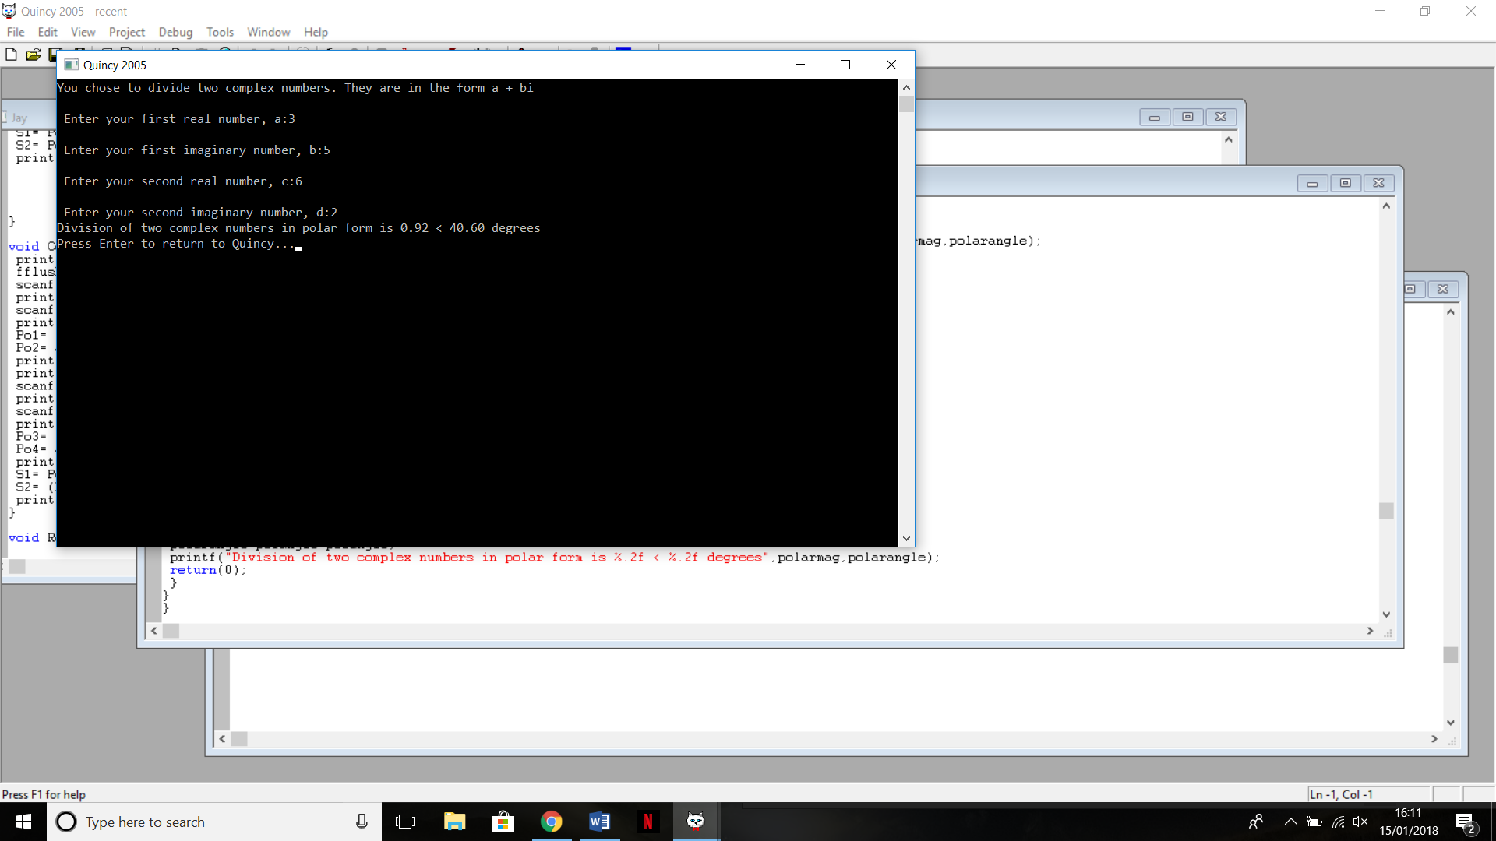

Figure 25 - Evidence for Option H in the top right quadrant

Figure 24 - Option H, division of two complex numbers with a result in the top right quadrant

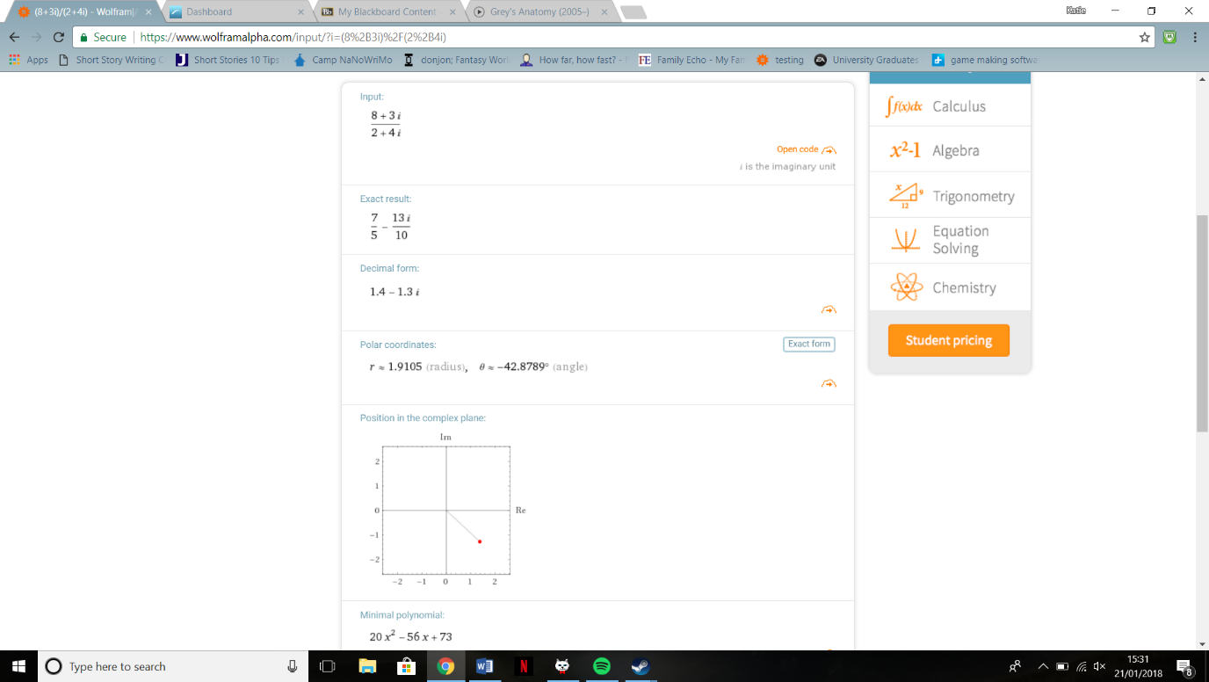Figure 26 shows Option H with a result in the bottom right quadrant. In figure 27 you can see the evidence for this, and it shows that both my magnitude and argument are correct, with the magnitude being rounded correctly.

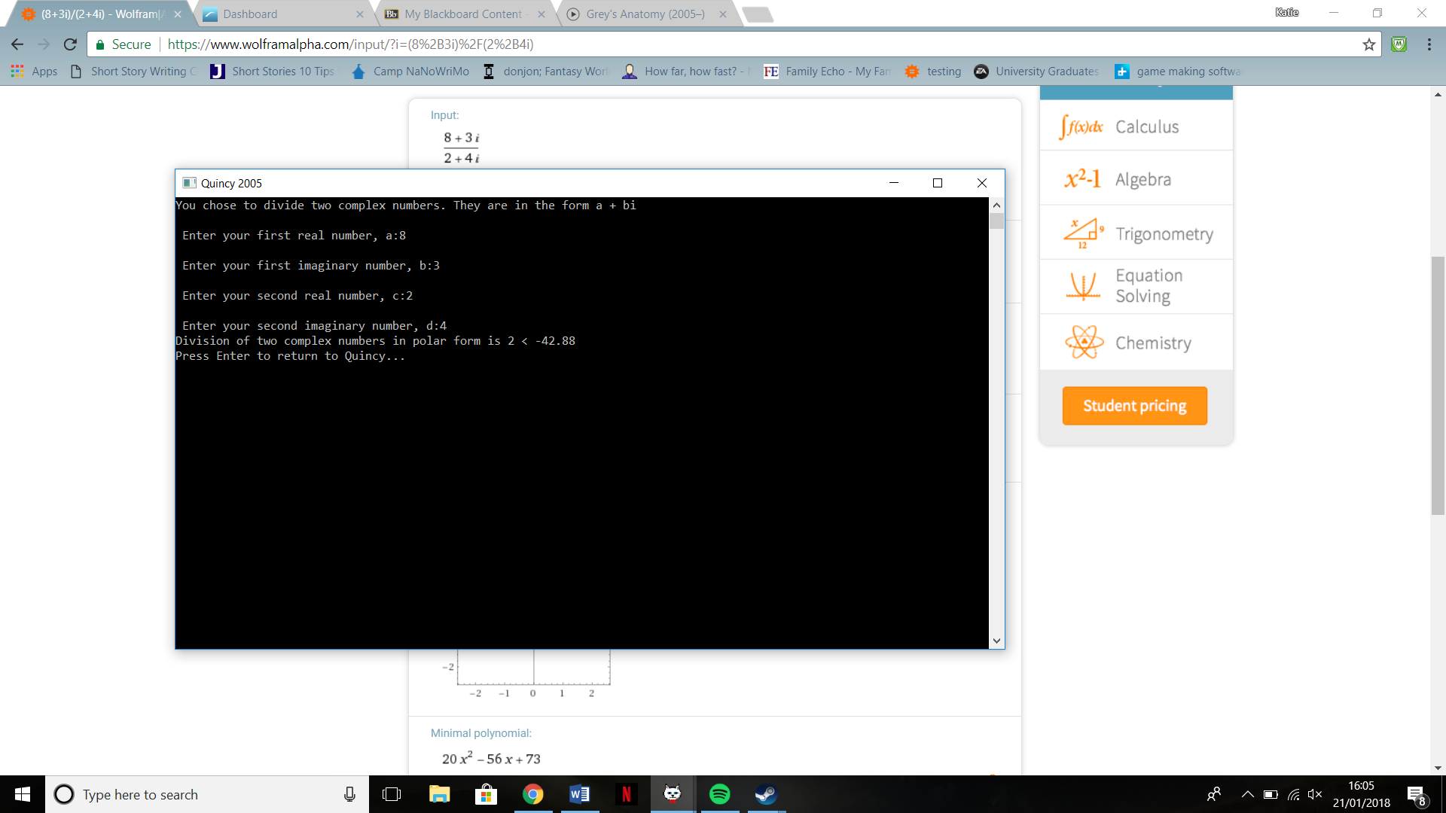

Figure 26 - Option H, division of complex numbers with a result in the bottom right quadrant

Figure 27 - Evidence for option H in the bottom right quadrant

Figure 28 shows option H with a result in the top left quadrant, and figure 29 shows the working out for this. As you can see both the magnitude and argument are correct in this quadrant.

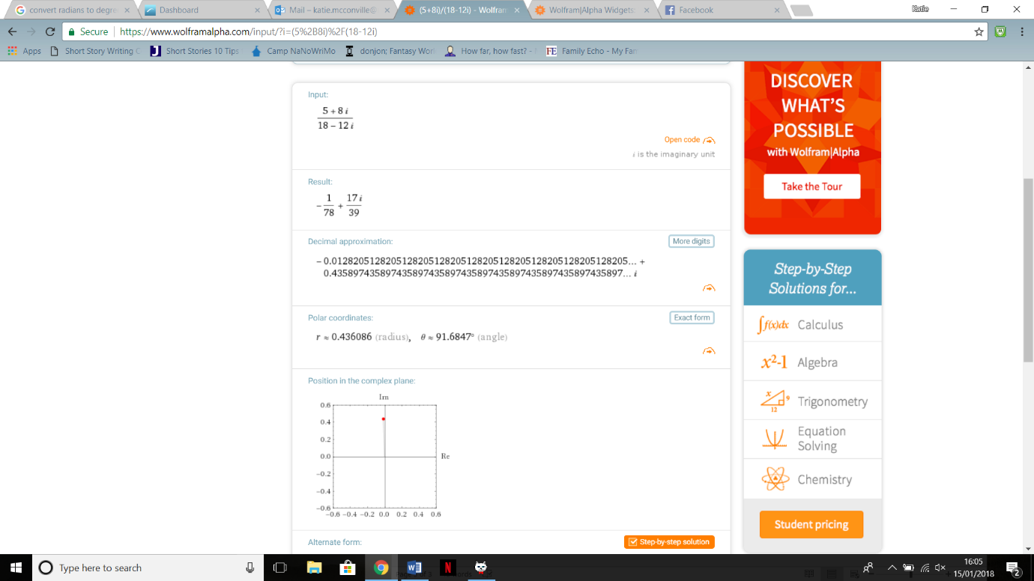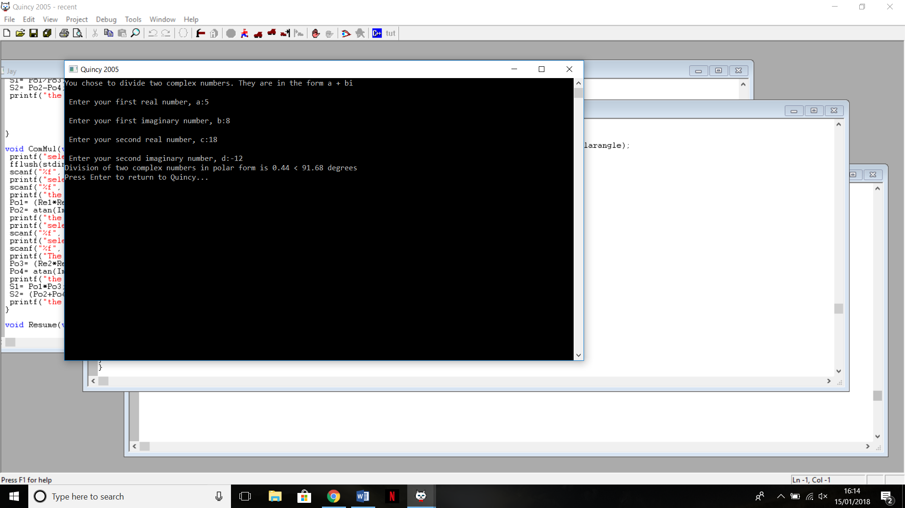

Figure 28 - Option H, division of two complex numbers with a result in the top left quadrant

Figure 29 - Evidence for option H with a result in the top left quadrant

Figure 30 shows Option H, with the result in the bottom right quadrant. Figure 31 shows the actual results of this in Wolfram Alpha. As you can see our angle for this quadrant is wrong. We re-tried the calculation and with other numbers and could not find any discernible pattern to easily correct the result.

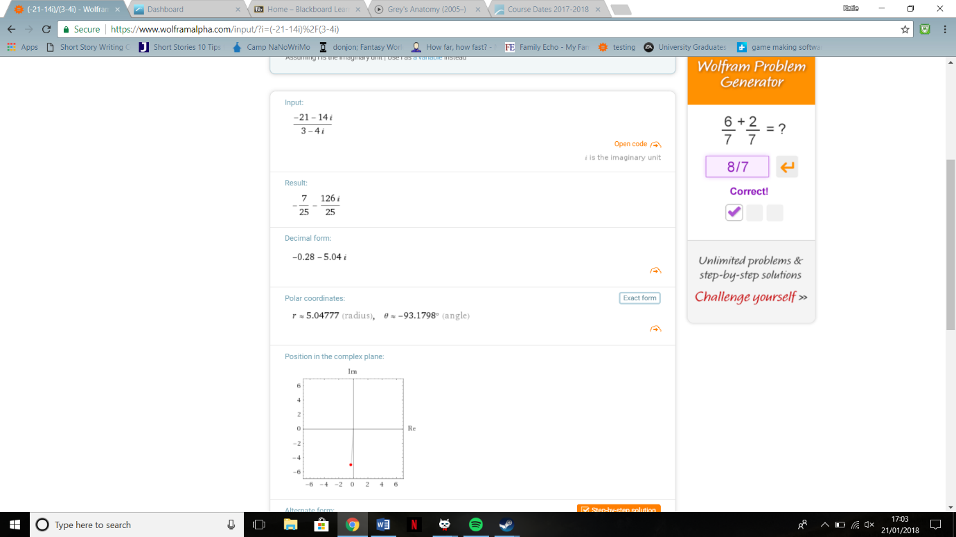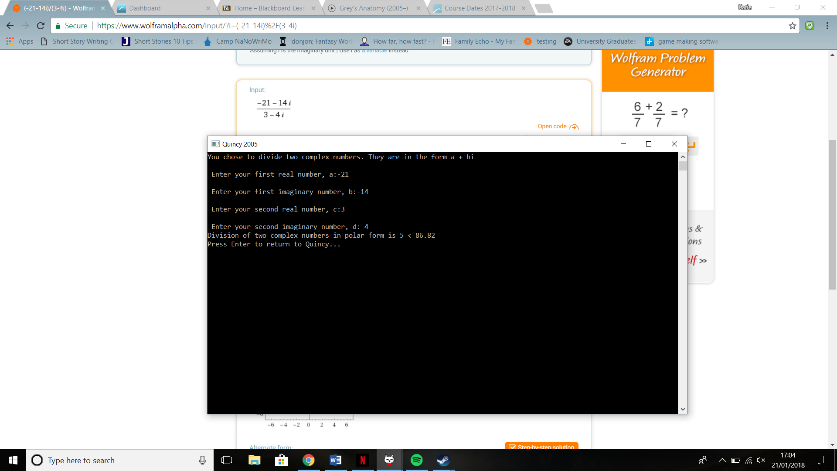

Figure 4 - Evidence for option H with result in the bottom left quadrant, showing the actual result

Figure 5 - Option H, division of complex numbers with a result in the bottom left quadrant

## Conclusion

Overall the program worked well, with issues only presenting themselves in the quadrants where the real number is negative in complex number multiplication, and having an as yet unexplained error in the quadrant where both imaginary numbers and real numbers are negative in complex numbers division. These errors mean I would have to say this program is a version 1.1.1, and in order for proper usage I would have to dedicate more time to understanding these issues so I can overcome them. Other than this, the program works exactly as expected.